Year 9
Autumn 1
Homework Booklet

Teacher Response:
WWW: ________________________________________________________________________
EBI: ________________________________________________________________________

Week 1: Using the internet research 5 interesting facts about a German company:
1._________________________________________________________
2._________________________________________________________
3._________________________________________________________
4._________________________________________________________
5._________________________________________________________
Challenge: What is the origin of the name Adidas ?:
_________________________________________________________

Week 2: Writing and Reading: Use the box below to choose the correct translation:
Sal

1.
Arzt
- teacher
- doctor
- waiter
- vet
- soldier
2.

Kellner

3.
Soldat

Challenge: How do you make these jobs feminine ?
4.
Lehrer

5.

Tierarzt

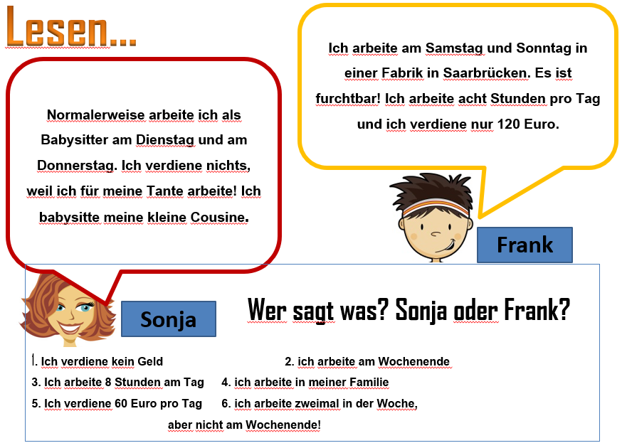Week 3:Read the text, answer the questions, who says each statement ?:
1. 4.
2. 5.
3. 6.
Week 4: Dictation: Listen to the sentences from google classroom which are spoken in German. You must copy out in German what is said:
1.
2.
3.
4.
5.
Challenge: Can you translate them into English too!
Week 5: Reading: Read and match the jobs and descriptions:
Week 6: Answer the following questions in German :
- Was ist dein Lieblingsfach und warum?
...............................................................................................................................................................................................................
- Was ist dein Hassfach und warum ? ........................................................................................................

