4.Year 10 Homework Booklet
Week 1: Grammar: Complete this table for the verb ‘trinken’ and ‘essen’. You may need to research online if you are unsure. If you get really stuck you can try German verb Conjugation: modal verbs, present, future, conjugation models | Reverso Conjugator
Present tense:
 | trinken (to drink) | essen (to eat)
ich
du
er/sie/es/man
wir
ihr
sie
Past tense:
 | trinken (to drink) | essen (to eat)
ich
du
er/sie/es/man
wir
ihr
sie
Future tense:
 | trinken (to drink) | essen (to eat)
ich
du
er/sie/es/man
wir
ihr
sie
Challenge: Can you do present past, and future for the verb ‘’ to write “gehen” be careful ! it’s a moving verb so will be different in the past tense. It uses “sein”
Week 2: Listening:

Peter and Elisabeth are discussing healthy living with their teacher, Frau Balke.
What do they think?
gesund =
meiner Meinung nach =

praktisch =
selten =
im Leben =
krank =
anderen =
fragen =
schmeckt mir (nicht)=

A | Sausage is healthy.
B | Salad is healthy.
C | Sausages make you ill.
D | Salad makes you ill.
Write the correct letter in the box.

(i) | Peter
(1)
(ii) | Elisabeth
Now read the transcript: check your answer again. Do you still agree with your answers?

F1 Peter, was ist deiner Meinung nach gesund?

M Ja, Frau Balke, ich esse praktisch jeden Tag Currywurst und Pommes, esse selten Salat, und war noch nie im Leben krank. Das muss also gesund sein, oder?

F1 Was meinen die anderen? Elisabeth?

F2 Also, wenn Sie mich fragen, Frau Balke, dann ist gesundes Essen Salat. Currywurst schmeckt mir gar nicht.

Challenge: Write a short description of your eating habits, are you healthy ?
………………………………………………………………………………………………………………
………………………………………………………………………………………………………………
………………………………………………………………………………………………………………

Week 3:Roleplay: Look at the roleplay and prepare your answer for each of the prompts below:
INSTRUCTIONS TO CANDIDATES: Sub-theme: Youth Culture
You are talking to your friend about Sport. Address your friend using ‘du’. ? – You must form a question!
- Du - Sport (zwei Details)

- Du – Sport im Fernsehen - Meinung

- ? Sportzentrum __________________________________________
- Du – letzte Woche – fit zu bleiben

- !
_______________________________________________________

Start with “ich spiele” (say 2 sports that you do)

Say I think sport on TV is .....
You could start with ich denke..

Put in order « du Sportzentrum ins oft wie gehst ? » how often do you go to the sport centre

Use past tense, start ‘letzte Woche habe ich…

The question is “Isst du gesund ?”

Challenge: Can you try this bullet point which is in another tense:

6. Was für Sport– Nächste Woche?
______________________________________________

Week 4: Translation in to English:
This tells us it has changed to past tense!
Ich esse oft in Restaurants in der Stadt. Am liebsten gehe ich in die Pizzeria mit meinen Freunden, weil es nicht sehr teuer ist. Letztes Wochenende haben wir Nudeln mit Tomatensauce gegessen. Am Freitag werden wir zu Hause kochen.

This indicates that it is the future tense
Key words:
am liebsten – most of all
teuer – expensive
gegessen - ate
zu Hause – at home

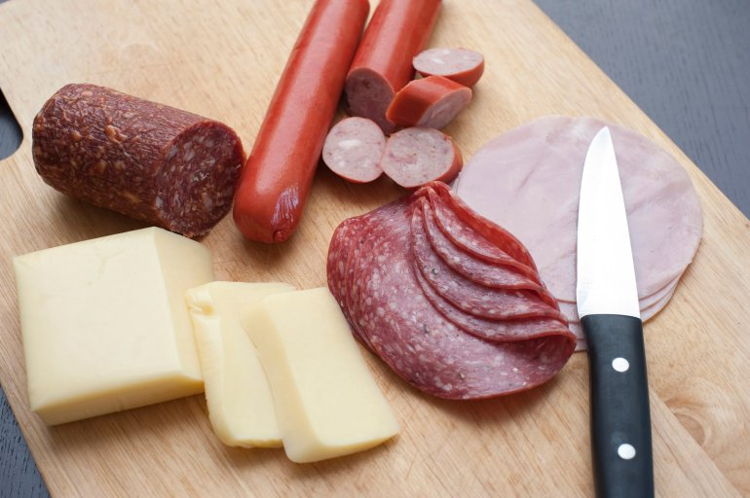

_______________________________________________________________________________________________________________________________________________________________________________________________________________________________________________________________________________________________________________________________________________________________________________________________________________________________
Challenge: Can you rewrite the last two sentences using ich ?

Week 5: Writing : Look at the task and prepare your answer. Write a new paragraph for each bullet point. Use the tips and vocab box to help you:
‘über dein Lieblingssport’ – tells you it is present tense hones

Deine Freundin Hanna aus der Schweiz hat dich über Freizeit und Sport gefragt. Du schickst Hanna eine E-Mail.

Schreib:

• etwas über dein Lieblingssport

• was du letzte Woche gespielt hast

• was du nächstes Wochenende mit Freunden machen wirst.

‘gespielt’ (played) tells you to use the past tense

‘nächstes Wochenende’ tells you it is in the future tense

Sport ist mir sehr wichtig.  Mein Lieblingssport ist...  Ich spiele auch gern.... | ……………………………………………………………………………………………………  ……………………………………………………………………………………………………  ……………………………………………………………………………………………………  ……………………………………………………………………………………………………  ……………………………………………………………………………………………………  ……………………………………………………………………………………………………  ……………………………………………………………………………………………………
Letzte Woche habe ich ....gespielt.  Ich fand es.....  Ich habe auch.....gespielt. | ……………………………………………………………………………………………………  ……………………………………………………………………………………………………  ……………………………………………………………………………………………………  ……………………………………………………………………………………………………  ……………………………………………………………………………………………………  ……………………………………………………………………………………………………  ……………………………………………………………………………………………………
Am Wochenende werde ich….  Ich werde mit Freunden….  Das wäre lustig/ spannend/ toll / klasse. | ……………………………………………………………………………………………………  ……………………………………………………………………………………………………  ……………………………………………………………………………………………………  ……………………………………………………………………………………………………  ……………………………………………………………………………………………………  ……………………………………………………………………………………………………  ……………………………………………………………………………………………………
Challenge – Can you remember any other BORDER phrases to add?
Week 6: Reading
STARTING POINT
Read all the statements through.
Read all the comments through.
What do these question mean ?
Wie oft =
Welches =
Siehst du fern =
Wie findest du ..=
Can you see any words that are in both ? are they helpful or “red herrings”?
What do the highlighted words mean ?
oft ? =
Gemüse =
siehst…fern =
finde(st) =

Healthy and unhealthy lifestyles
Find the correct answer to each question.
Write the correct letter in the box.

(a) | Wie oft treibst du Sport?
(1)

(b) | Welches Gemüse isst du gern?
(1)

(c) | Siehst du jeden Tag fern?
(1)

(d) | Wie findest du Fastfood?
(1)

A | Ich denke, das ist sehr ungesund.
B | So oft wie möglich.
C | Ich hasse Karotten, aber Blumenkohl schmeckt mir sehr gut.
D | Mein Lieblingssport ist Tennis.
E | Ich sitze zwei Stunden pro Tag vor dem Fernseher.
F | Viele Teenager essen Fastfood.

Challenge: Can you translate the 6 sentences into English ?
1.______________________________________________
2.______________________________________________
3.______________________________________________
4.______________________________________________
5.______________________________________________
6.______________________________________________

